**Submission Instructions:**

Your submission for this assignment should be a Word document that includes the following screenshots, each labeled for the step that the screenshot represents. For each of the steps below, ensure that you also include a description of the steps in your document to demonstrate your understanding of the steps that you have performed so far:

1. Show evidence that the three *collections* have been created in Strapi by producing screenshots for each of the *collection* types after they are created. Include a description of your understanding of this step.
   1. Airline’s collection:

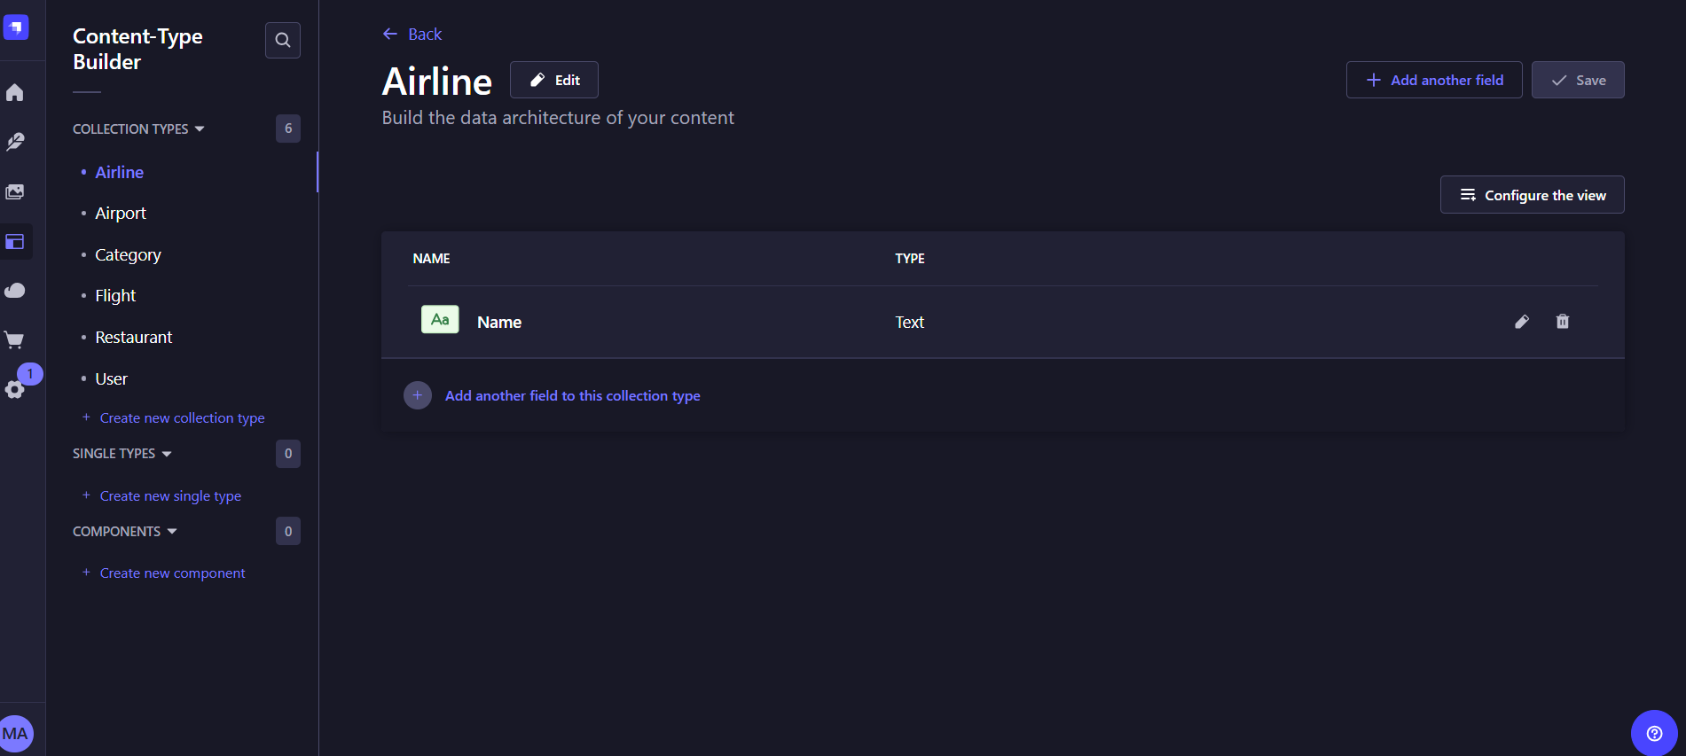

* 1. Flight’s collection:

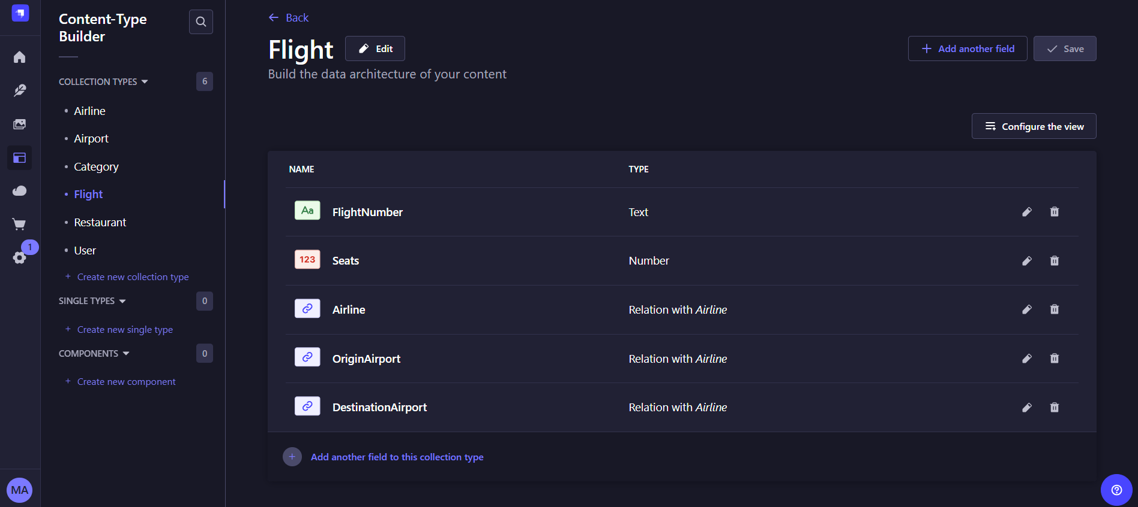

* 1. Airport’s collection:

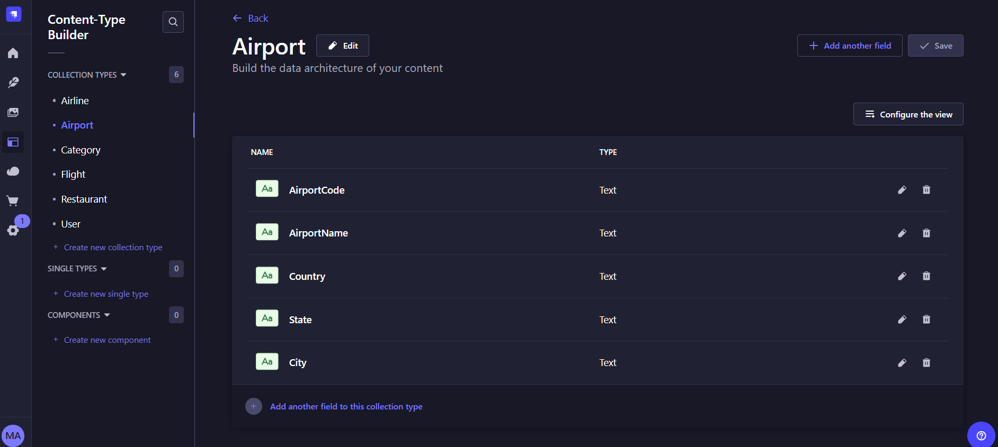

1. Show evidence that you have created data for the Flights API by pointing your browser to each of the *collection* types and taking a screenshot of the output.
   1. Airline’s data:

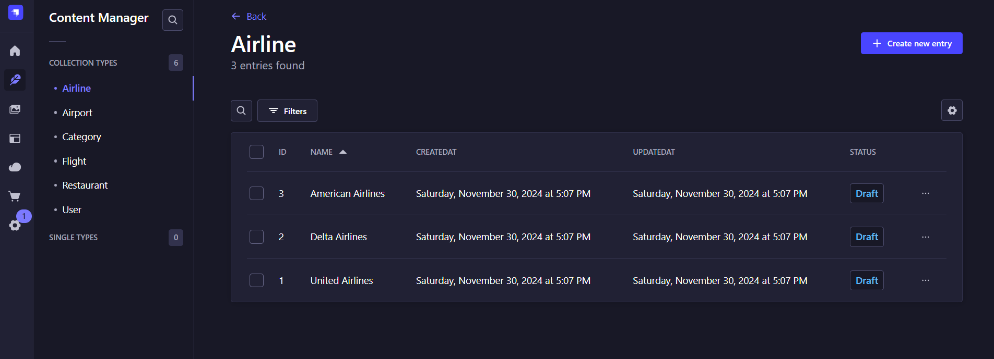

* 1. Flight’s data:

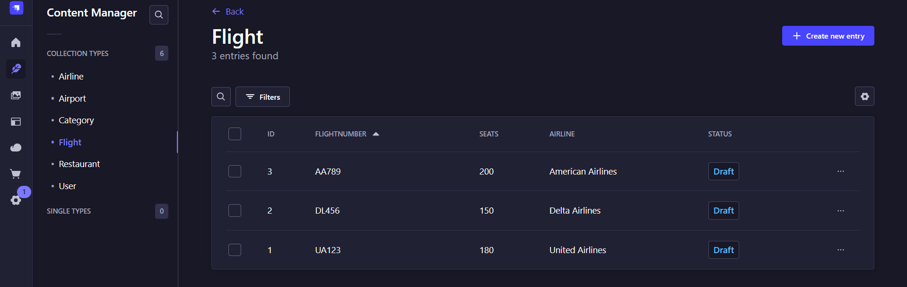

* 1. Airport’s data:

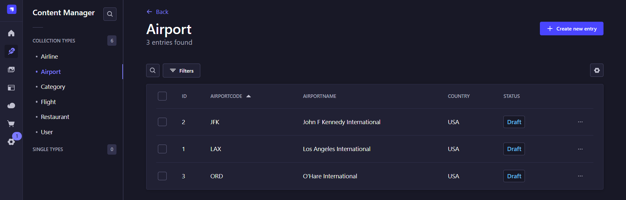

1. Show evidence that you have submitted the GET *request* by taking a screenshot of the *request* and response in Postman.
   1. Airline’s GET request:

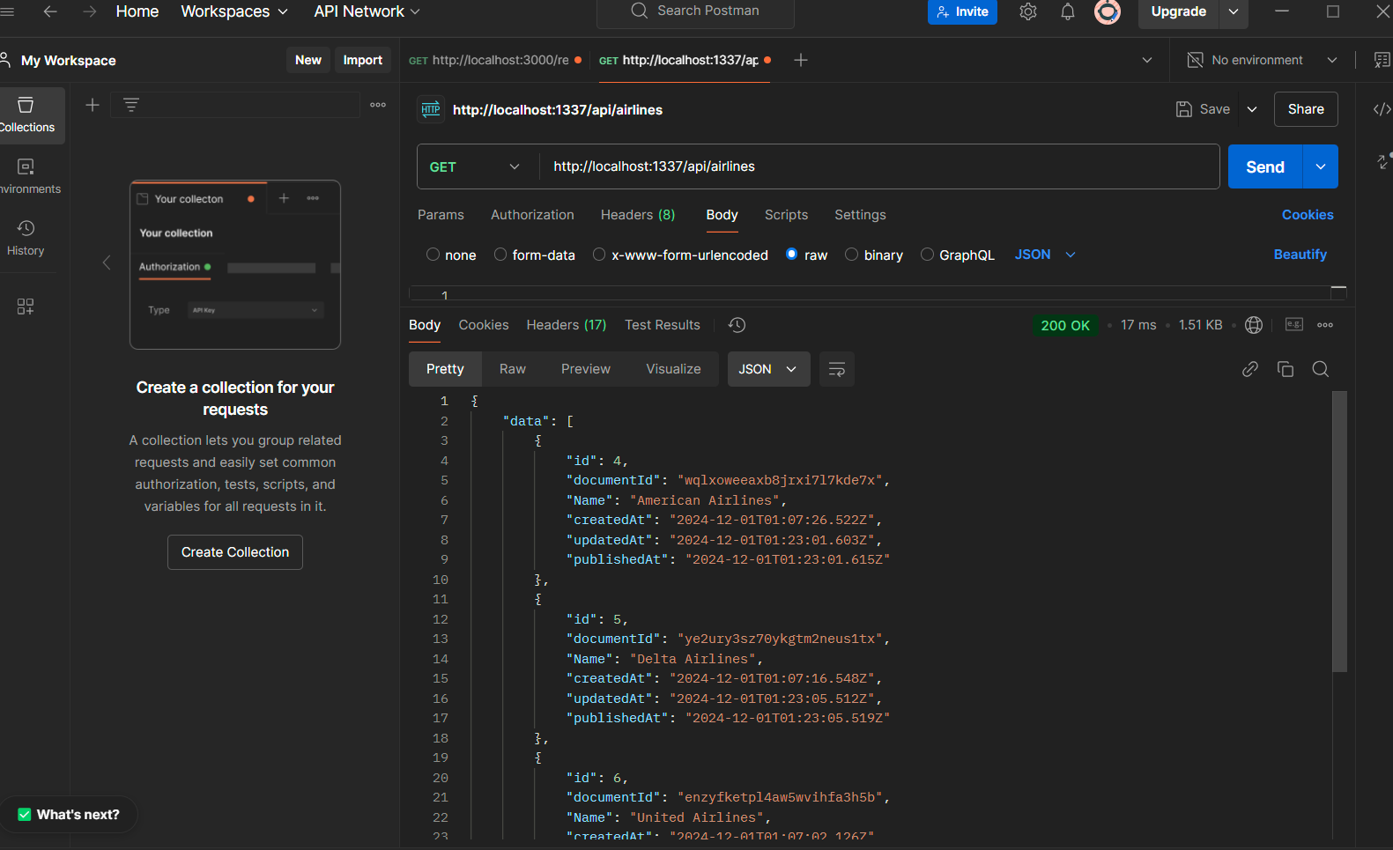

* 1. Flight’s GET request:

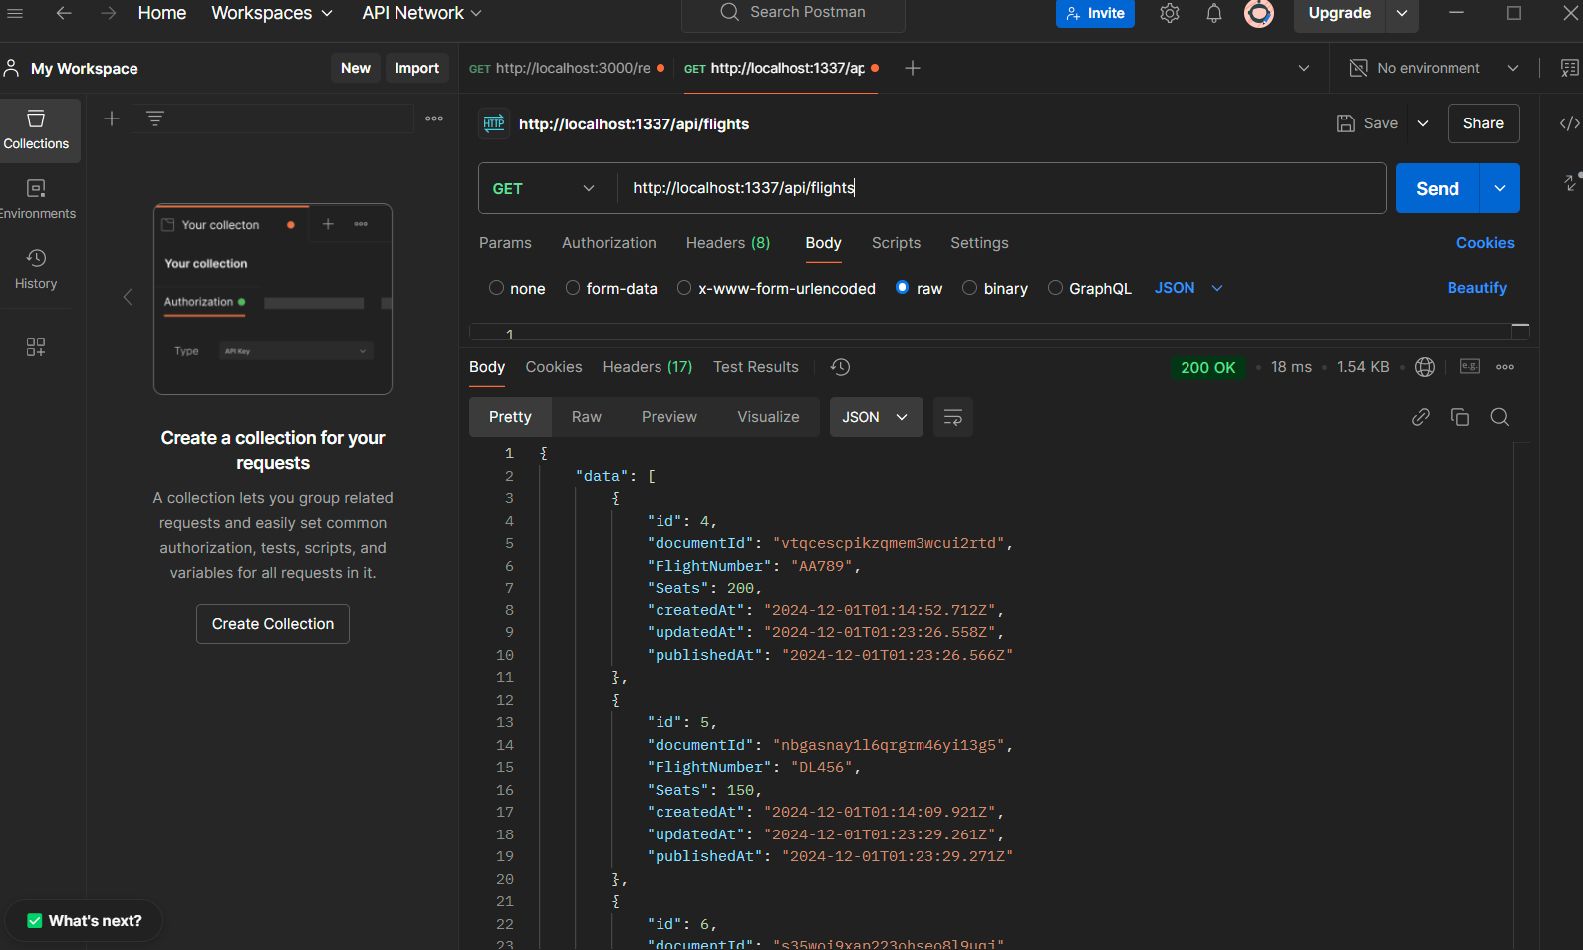

* 1. Airport’s GET request:

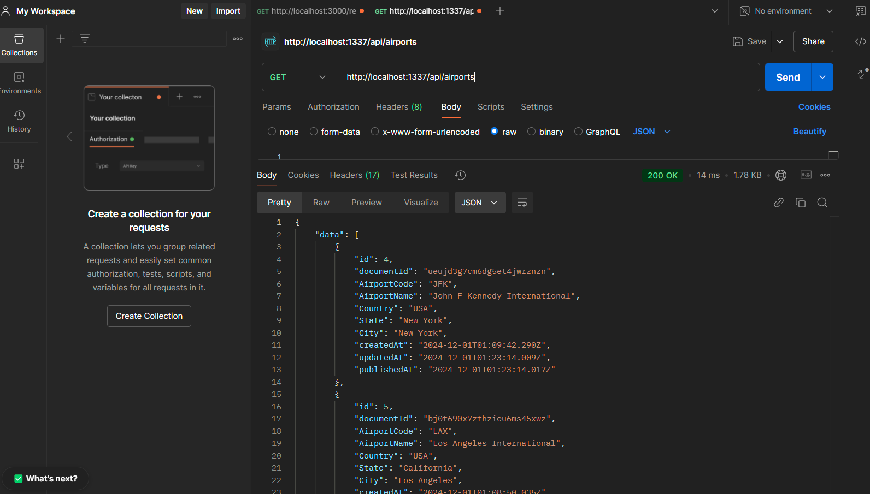

1. Show evidence that you have submitted the GET *request* by taking a screenshot of the *request* and response in Postman.
   1. Flight’s GET Request for first data point:

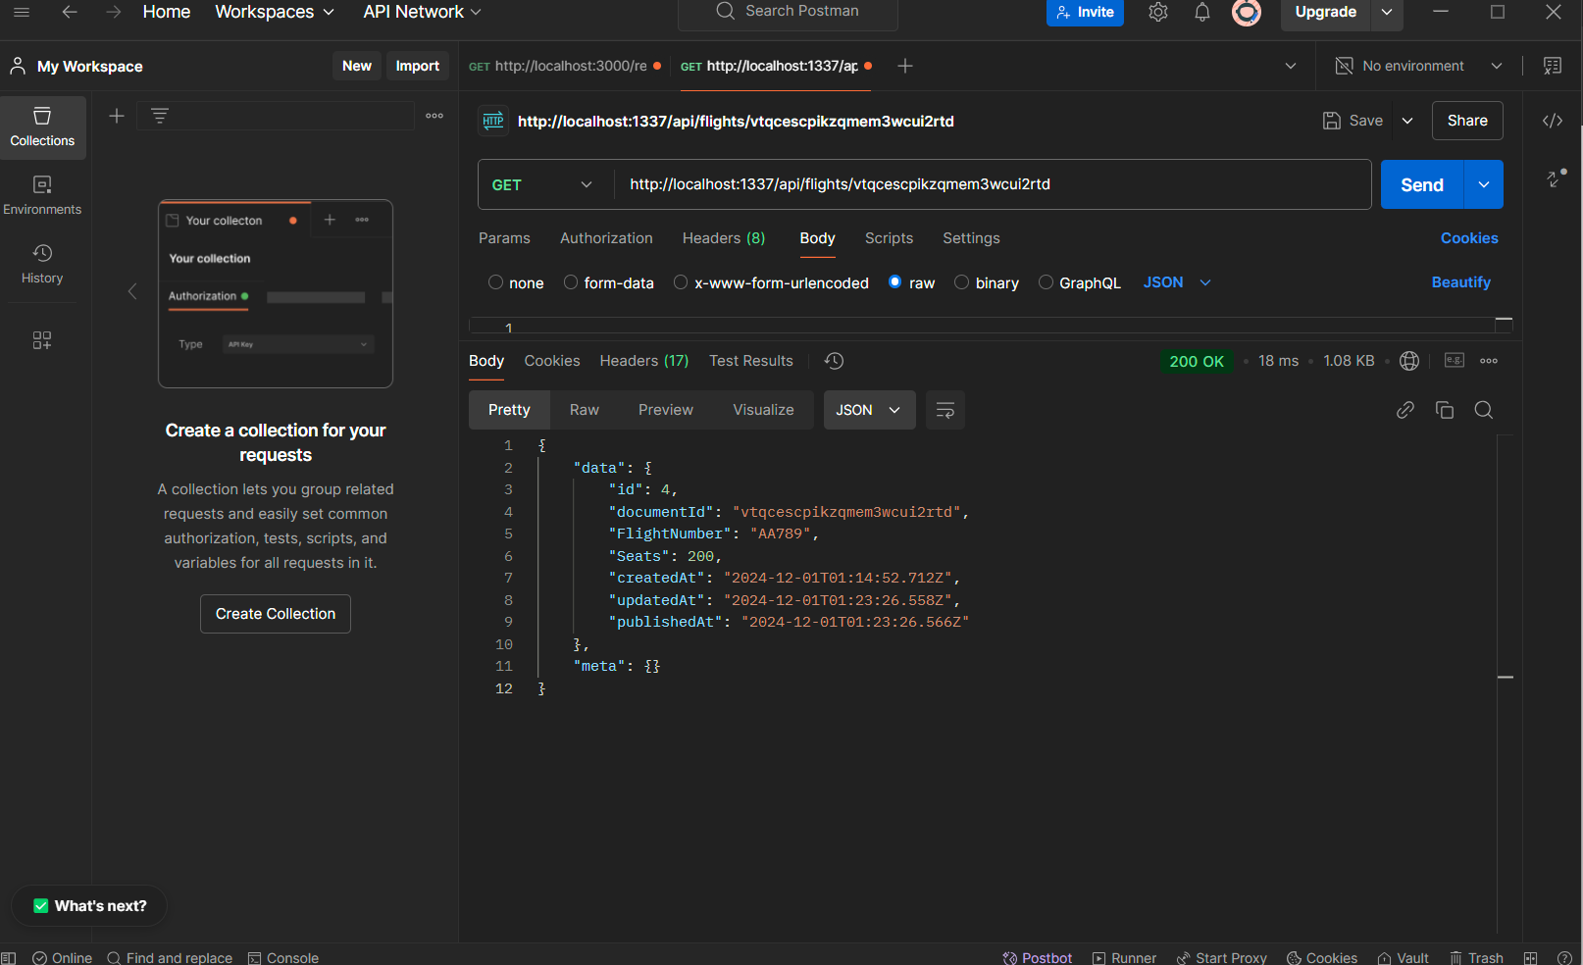

1. Show evidence that you have submitted the POST *request* by taking a screenshot of the *request* and response in Postman.
   1. Flight’s new data point (LH450):

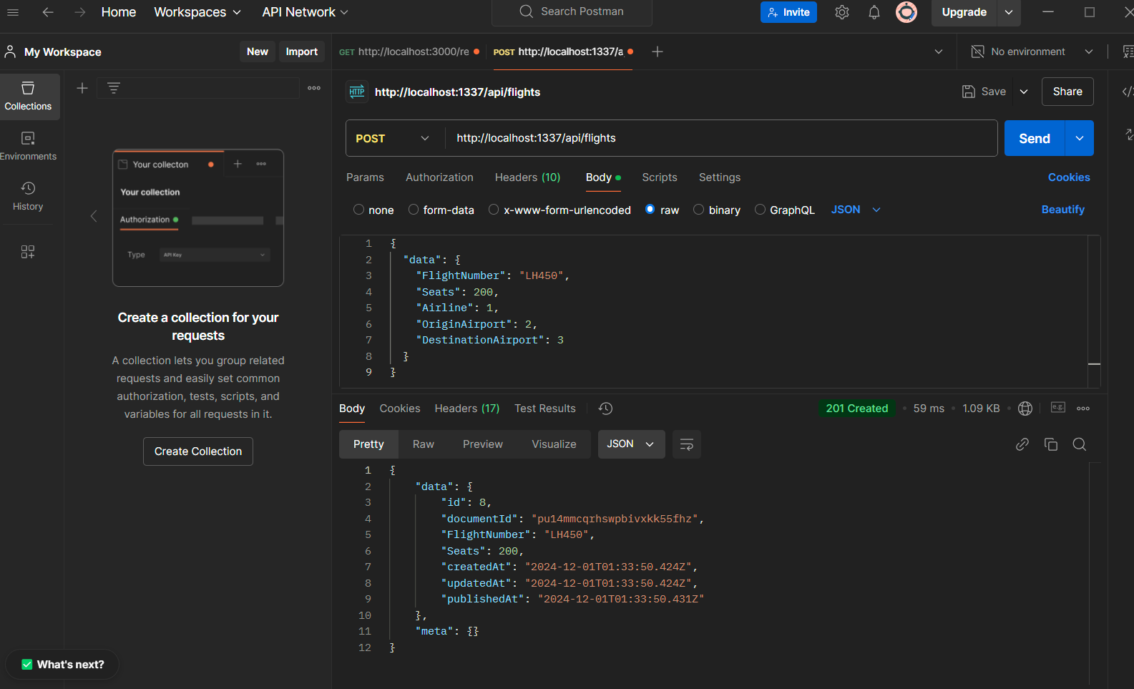

1. Point your browser to the Flights Collection and include a screenshot of the browser to show that a new flight has been created.
   1. Flights collection browser screenshot:

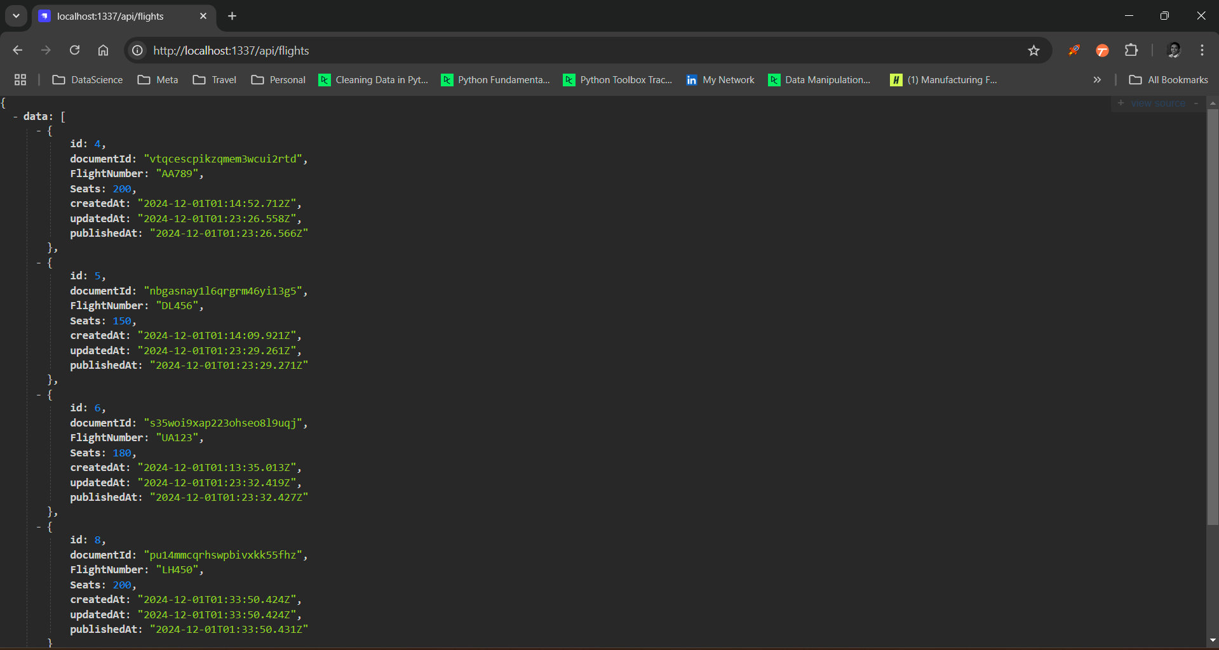

* 1. Flight’s new data point screenshot:

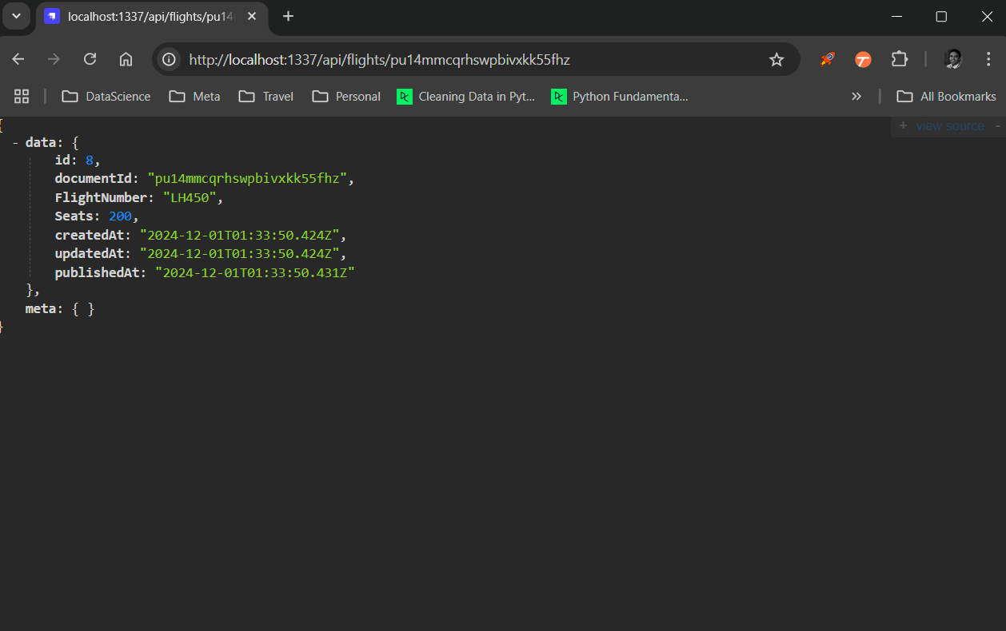

1. Show evidence that you have submitted the POST *request* by taking a screenshot of the *request* and response in Postman.
   1. In Postman, I’ve used PUT for http://localhost:1337/api/flights/vtqcescpikzqmem3wcui2rtd

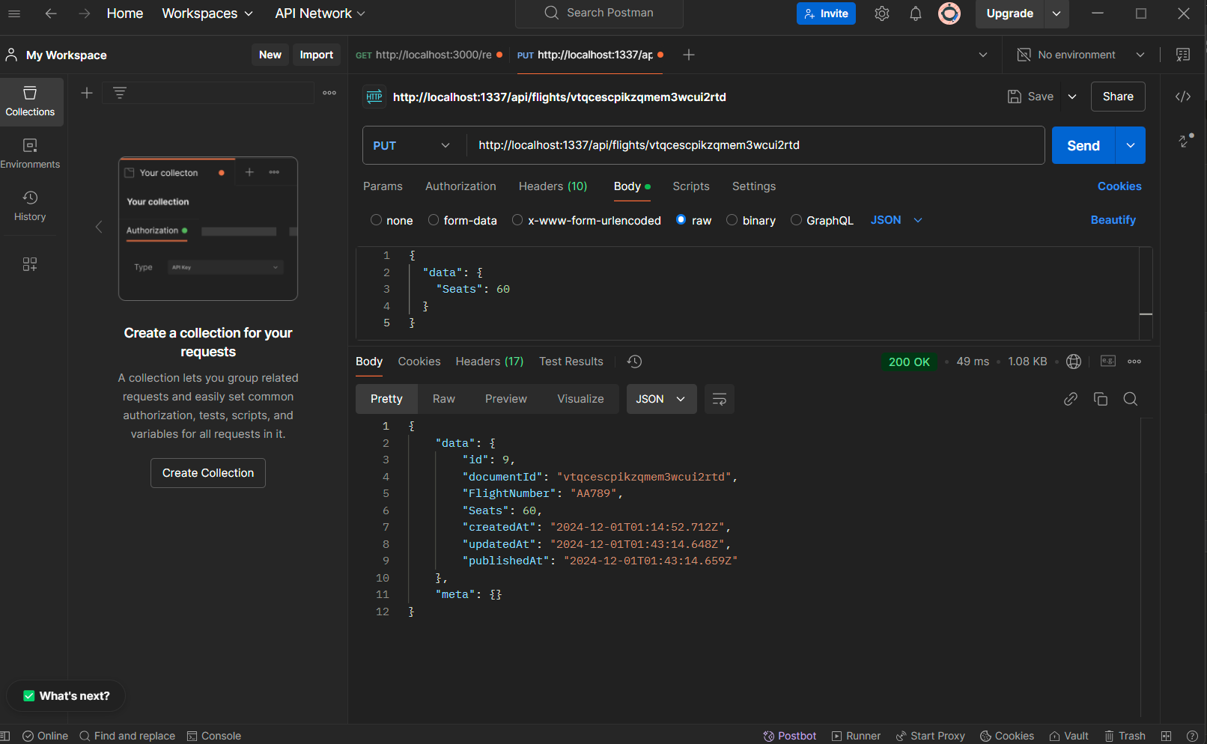

1. Point your browser to the Flights *Collection* and include a screenshot of the browser to show that flight has been updated.
   1. Flight’s Collection web browser:
      1. For documentID: "vtqcescpikzqmem3wcui2rtd", seats got updated to 60  
         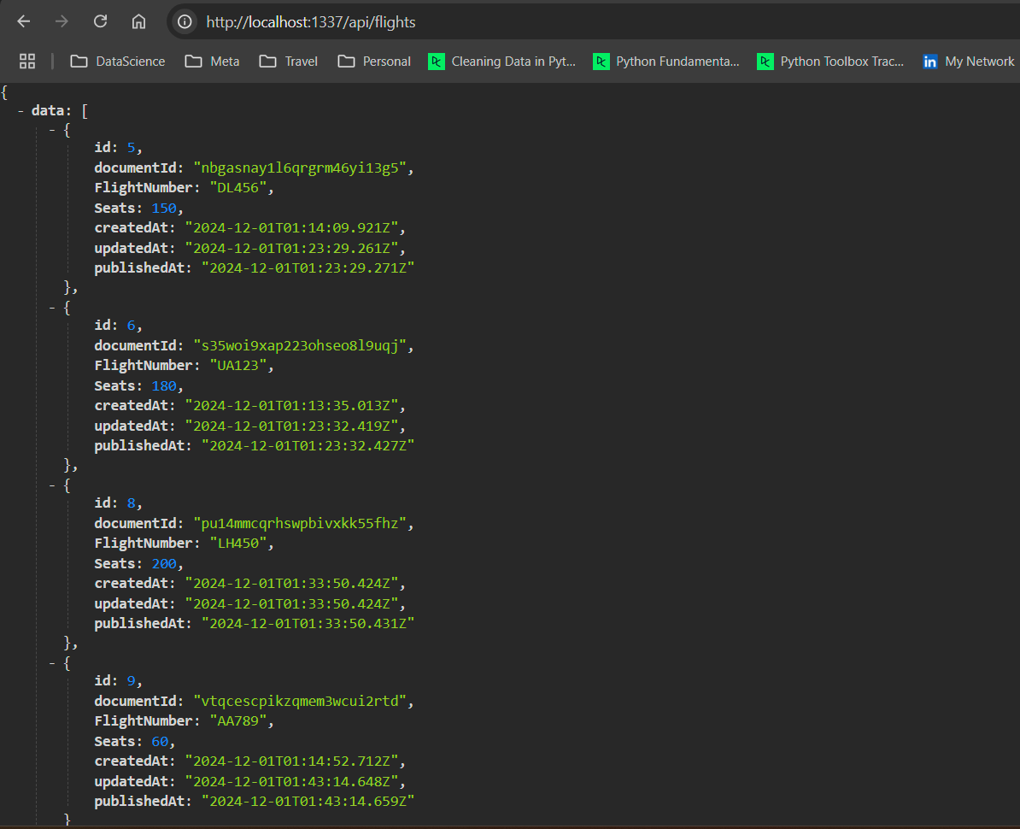
2. Show evidence that you have submitted the DELETE *request* by taking a screenshot of the *request* and response in Postman.
   1. Deleted documentsID: pu14mmcqrhswpbivxkk55fhz OR (Flight #: LH450)  
      http://localhost:1337/api/flights/pu14mmcqrhswpbivxkk55fhz

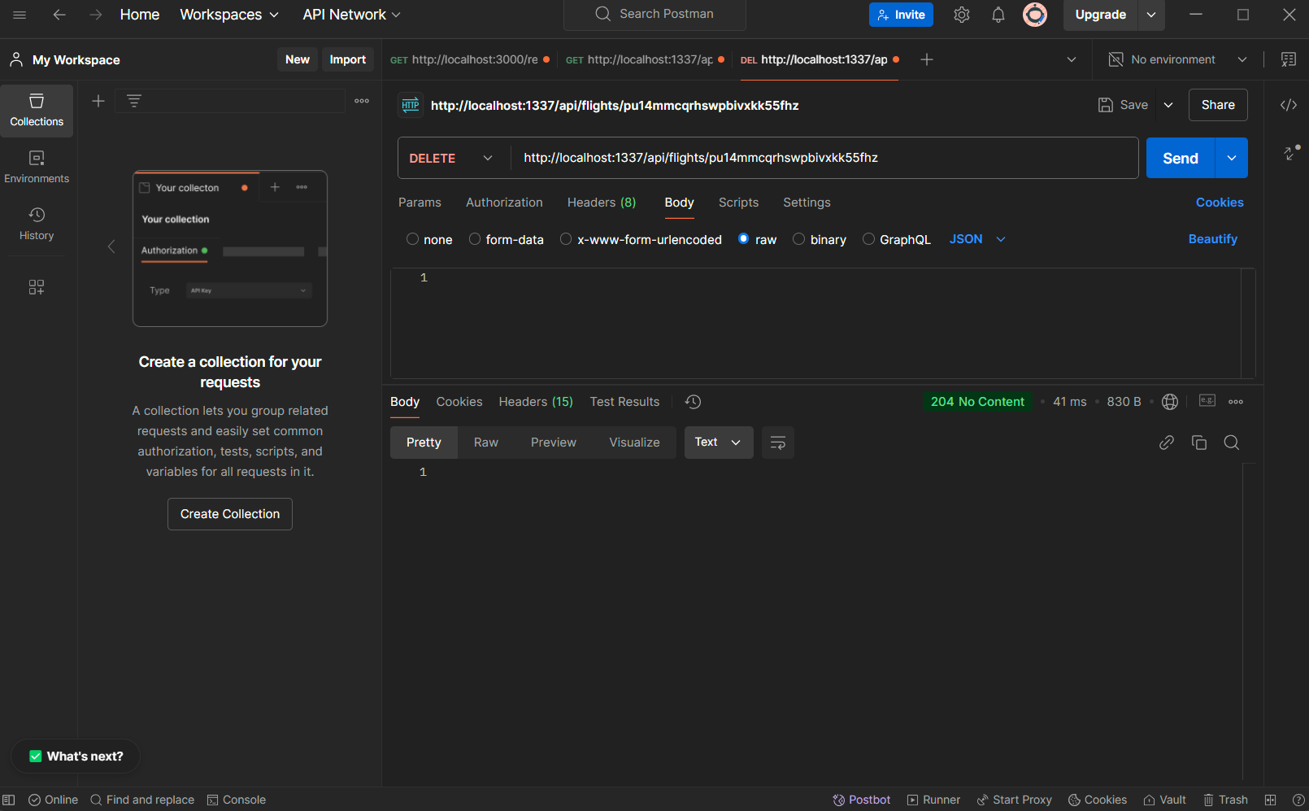

1. Point your browser to the Flights *Collection* and include a screenshot of the browser to show that the flight has been deleted.
   1. Flight Collection Browser:

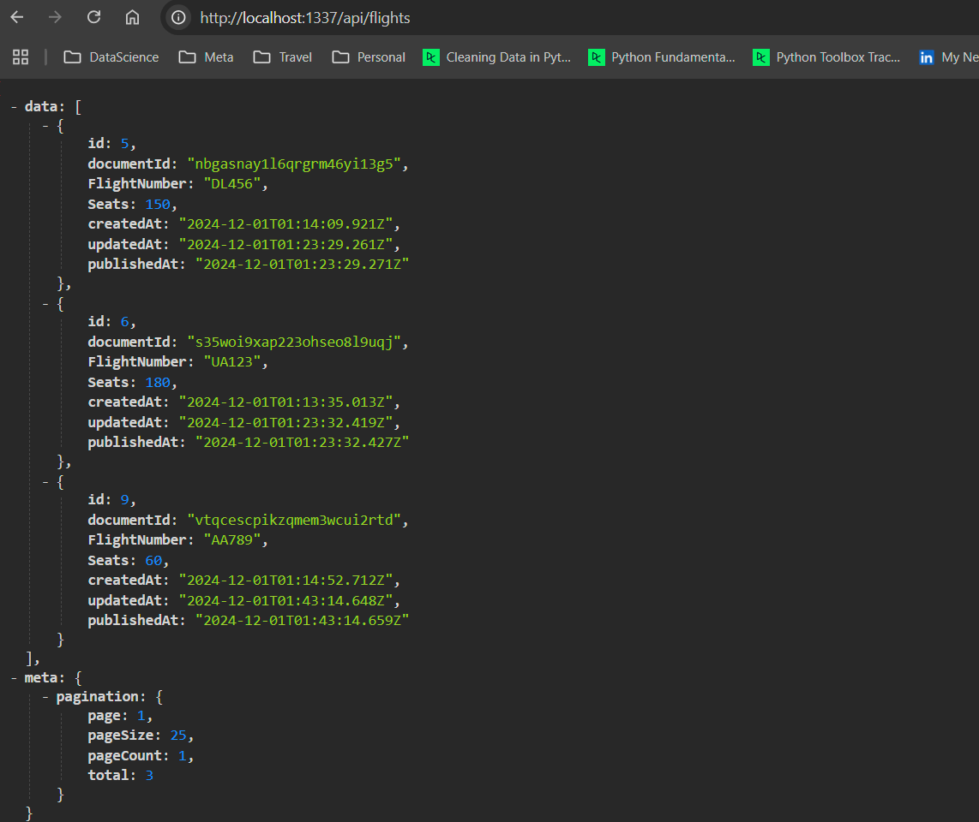

1. Run the code to create a Python application to make a GET *request* to your airline application.
   1. VS Code, python script to execute the GET request:

